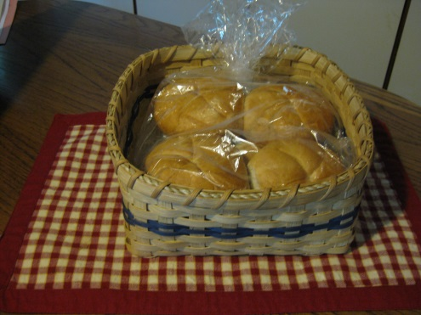

Bun Basket

This simple basket will hold your buns (also good for paper plates) for any picnic or buffet. It is a quick, easy project great even for beginning weavers.

Materials:

½” flat natural reed

¼” flat dyed reed your choice of color

¼” flat natural reed

#2 round reed more than twice diameter of basket

Sea grass the diameter of the basket.

**Weaving the Base:**

Cut 18- ½” flat natural stakes 22” long. Soak all stakes along with the #2 round reed. Remove the stakes from the water and lay out 8 stakes smooth side down. Now weave across those stakes with the remaining 8 stakes smooth side down in an over under pattern. Center the stakes, checking the ends are even on all sides. Adjust spacing until the base measures 8” X 8”. Remove the round reed from the water after it is quite pliable and weave it around the basket with a twining pattern, securing it flush against the edge of the base. Press the twining as close to the base as possible and upturn the stakes.

**Weaving the Sides:**

Weave three rows of ½” flat natural reed. Next weave 3 rows of ¼” dyed reed. Then weave 3 more rows of ½” natural reed. Dampen your weaving by spritzing the INSIDE if needed but try to keep the color from becoming wet enough to run or stain the natural reed. Pack the rows, make sure your stakes are straight and shape the basket by gently squaring the sides. Now, weave a ¼” natural row at the top to be hidden under the rim. Leave a small gap between the last ½” row and the ¼” row so there is room to lash the rim. Clip flush all stakes that are behind the top row and measure and cut the remaining outside stakes so that they tuck neatly hiding behind the stakes on the inside of the basket.

**Rimming the Basket:**

Cut two pieces of ½” natural reed with a 2” overlap. Clip one to the inside, and the other to the outside of the top row, smooth side out. Fit sea grass in the gap. Now choose a ¼” lasher that is at least 2 ½ times the diameter of the basket. Soak until pliable. Keeping the lasher wet, lash between each stake around the diameter of the basket. Tuck and clip. Now shape your basket and allow to dry. Stain basket if desired.

Don’t forget to sign and date your basket. Enjoy!

*Pattern by Tanglewood Baskets 2016 website: tanglewoodbaskets.com*